A. An organic compound is analysed and found to contain the following percentage composition by mass: 58.8% carbon, 9.8% hydrogen, and the rest is oxygen.
The relevant spectra are shown below:
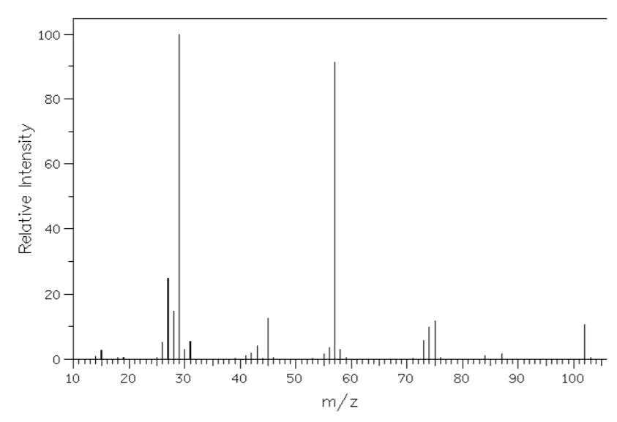

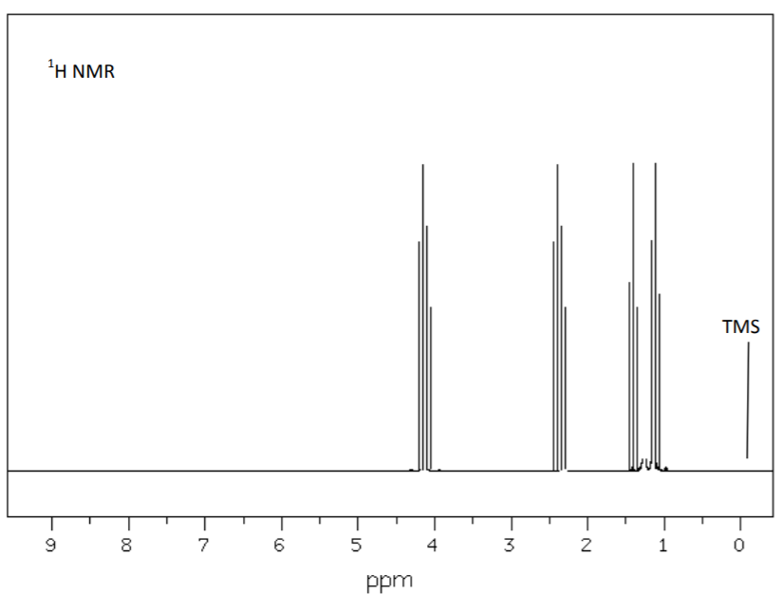
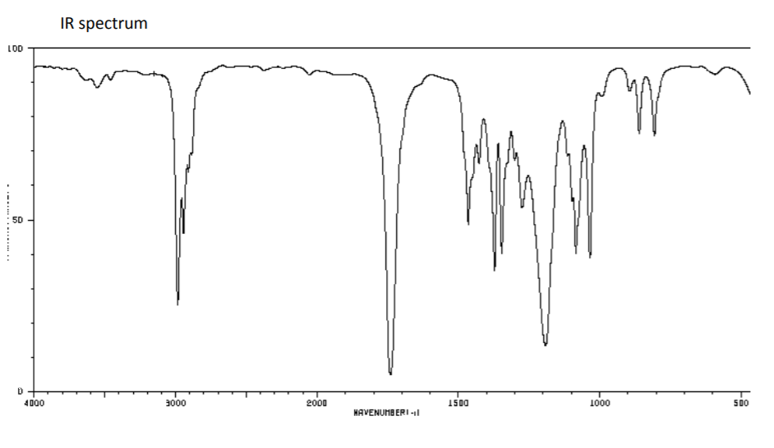
- Calculate the empirical formula of the compound. 2 marks

- What is the molecular formula of the compound? 2 marks

- What information can be deduced from the IR spectrum at 1250 cm⁻¹ 1 mark
and at 1750 cm⁻¹?

- Draw the structural formula and name of the compound in (b) above. 3 marks

- What is the significant of a singlet at 2.0 ppm on ¹H NMR? 1 mark

- Give the name of the compound 1 mark

- What are the names of the two possible raw materials for the production of 2 marks
(e) above?

- What type of reaction forms this compound? 1 mark
- *What is the relevance of the peak at 0 on the ¹H NMR spectrum labelled TSM? 1 mark

B. Given the following two molecular compounds (CH₃)₂CHCOOCH(CH₃)₂ and CH₃CH₂COOCH(CH₃)₂ Outline the similarities and differences between the IR, 1H NMR and 13C NMR spectra of each molecule by completing the table below. The table for ethanol is filled in for you. 6 marks
Compound | IR Spectrum | ¹H NMR | ¹³C NMR
Ethanol | Strong absorption at:  2850-3300 due to C-H (alkane)  3200-3550 due to O-H (alcohol) | Three sets of peaks  - A singlet representing the OH  - A quartet representing the CH₂  - A triplet representing the CH₃ | Two peaks

C. Below is a reaction pathway of two compounds A and C.
Compound A Compound C
H⁺(aq)
Cr₂O₇²⁻(aq)
H₂O(g)
H₃PO₄(s)
Reaction 2
Reaction 1
butan-1-ol propanoic acid

Reaction 3
H₂SO₄(aq)

+

Compound D Compound E
- Give the systematic name for Compound A. _________________________ 1 mark

- What type of reaction is 3 marks
  - Reaction 1 _______________________________________________

  - Reaction 2 _______________________________________________

  - Reaction 3 _______________________________________________

- Identify compounds 2 marks
- Compound D _____________________________________________

- Compound E _____________________________________________

- Draw the structure of the heavier compound that results from reaction 3, 1 mark
showing all bonds.

- The IR spectrum of the compound in question d) above contains 3 peaks of high absorption. Give the range in wave number (cm⁻¹) where each peak is likely to be found and the bond that it represents. 3 marks

Bond | Absorption range (cm⁻¹)

